COMPANY RATING SYSTEM

PROBLEM STATEMENT
&
Analysis

One of the major problem in the corporate world is the job satisfaction of the employee.they are not happy with what they have chosen to work for. Some of them are not happy with the salary,some are unsatisfied with the work environment.
There are many things that a newcomer to a firm don’t know about the place they will be working on. This is either due to unawareness of the person or there are less known fact about the office environment of the firm.
The best way to know about a company is to ask to the employee that are currently working in or have worked earlier. And also,it not convenient for a new person in the industry to make contact with the current employees.
So here we are proposing a web based solution -”company review system”,which will have profiles for various companies and take reviews of the current and former employees of that company.
This will definitely help the newcomers to make a better decision in choosing the perfect employer.
Our solution will be web based and some of the features are as follows:-

- Signup page: first users have to make an account .
- Login page:registered users shoud login to their profile.
- Company review page: once the user account is setup it will ask the user to rate their company in terms of overall rating,pros and cons ,food,work culture,fun or research oriented environment ,promotional growth average salary and other benifits provided by the company.
- Search page: there would also be a search page to find for a company to know about its overall rating .
Company feed: The homepage will also give the news feed about the most rated company in the database.

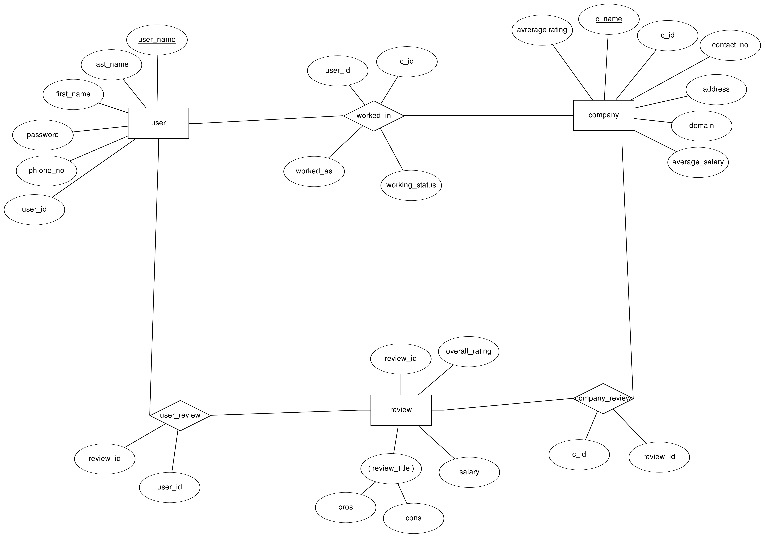

ENTITY SETS

user-user_id,first_name,last_name,phone_no,password,email_id

description-this entity nset contains information about the user (eg,name,phone_no etc)

review-
review_id,overall_rating,review_title,pros,cons,salary

this entity set stores information about
the review an user has given to an company

company-
company_id,company_name,address(composite),contact_no,domain,average_rating,average_salary

this entity set contains information about the company which has been registered over portal.

FUNCTIONAL DEPENDENCIES

user
F={user_id->email_id,phone_no}

company
F={company_id->company_name}

TABLE1-
USER
ATTRIBUTES--
user_id pk
email_id
phone_no
password
first_name
last_name

TABLE2
COMPANY

ATTRIBUTES

company_id pk
company_name
contact_no
domain
avg_rating
avg_salary
address

TABLE3
REVIEW

ATTRIBUTES
review_id pk
overall_rating
review_title
pros
cons
salary

RELATIONSHIP TABLE

TABLE 1
USER_REVIEW
ATTRIBUTES
user_id
review_id

TABLE2

COMPANY_REVIEW
ATTRIBUTES
company_id
review_id

TABLE3
WORKED_IN

ATTRIBUTES

user_id
company_id
working_status
job_title

Procedures used in the project:-

1->new_user(first_name,last_name,user_name,email,phone_no,p_word)
It creates a new user in the database by adding these data to the user table.
2->new_company(company_name,phone,address,domain)
It adds a new company in the database by adding it to the company table.
3->new_review(overall_rating,salary,review_title,pros,cons)
it adds a new review in the review table.
4->my_rating(user_id)
it returns the total review done by the user with user_id
with all information about the company and the review
about the company.
5->find_review_id(company_id,user_id)
It returns the review_id of the review given by user with user_id for company
with company_id.
6->delete_review(user_id,company_id,review_id)
This deletes all the data regarding the review with review_id from
all table.

Trigger used in the database :-
1-> average_rating()
this trigger updates the average rating of the company whose new review has
been inserted into the review table. This fires after insertion on company_review
table.
2->average_rating2()
this trigger updates the average rating of the company whose review has
been deleted from the review table. This fires after deletion on company_review
table.
3->average_salary()
this trigger updates the average salary of the company whose new review has
been inserted into the review table. This fires after insertion on company_review
table.

4->average_salary2()
this trigger updates the average salary of the company whose review has
been deleted from the review table. This fires after deletion on company_review
table.
5->after_update_trigger()
this trigger is fired after update is done in one of the existing
review. This updates the avg_rating and avg_salary in the company
table.

Rahul kumar 160001047
Harsh vardhan 160001025

